Create, Modify, and Remove File and Folder Permissions in Windows

Head's up: You'll experience a delay as the labs initially load, particularly for Windows labs.

**Introduction**

In this lab, you'll learn the foundations of how managing user permissions works on a Windows machine. Using the new Powershell commands you learned, you'll fix up the permissions of some files and folders.

**What you’ll do**

In this lab, you'll create and change folder permissions using the Windows Command Line Interface (CLI), known as Powershell. In this exercise, you'll:

* access administrative privileges to use Powershell in Windows.
* view file and folder permissions using the GUI and Powershell commands.
* modify the permissions for both files and directories by granting and removing specific permissions using ICACLS in Powershell.
* modify the permissions for groups using the GUI and Powershell.

**You will have 60 minutes to complete this lab.**

# **Create, Modify, and Remove File and Folder Permissions in Windows**

External IP address



content_copy

username



content_copy

password



content_copy

External IP address



content_copy

username



content_copy

password



content_copy

**Introduction**

In this lab, you'll learn the foundations of how managing user permissions works on a Windows machine. Using the new Powershell commands you learned, you'll fix up the permissions of some files and folders.

**Head's up**: You'll experience a delay as the labs initially load (particularly for Windows labs). So, please **wait a couple of minutes for the labs to load**. Please also make sure to access the labs **directly through Coursera** and not in the Qwiklabs catalog. If you access the labs through the Qwiklabs catalog, you will *not* receive a grade. (As you know, a passing grade is required to matriculate through the course.) The grade is calculated when the lab is complete, so be sure to hit "**End Lab**" when you're done!

You'll have 60 minutes to complete this lab.

**What you'll do**

In this lab, you'll create and change folder permissions using the Windows Command Line Interface (CLI), known as Powershell. In this exercise, you'll:

* access administrative privileges to use Powershell in Windows.
* view file and folder permissions using the GUI and Powershell commands.
* modify the permissions for both files and directories by granting and removing specific permissions using ICACLS in Powershell.
* modify the permissions for groups using the GUI and Powershell.

Start the lab

You'll need to start the lab before you can access the materials in the virtual machine OS. To do this, click the green “Start Lab” button at the top of the screen.

**Note:** For this lab you are going to access the **Windows VM** through your **local RDP Client**, and not use the **Google Console** (**Open GCP Console** button is not available for this lab).

Start Lab

After you click the “Start Lab” button, you will see all the connection details on the left-hand side of your screen. You should have a screen that looks like this:

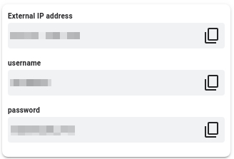

**Note:** Working with Qwiklabs may be similar to the work you'd perform as an IT Support Specialist; you'll be interfacing with a cutting-edge technology that requires multiple steps to access, and perhaps healthy doses of patience and persistence(!). You'll also be using **RDP** to enter the labs -- a critical skill in IT Support that you’ll be able to practice through the labs.

**Accessing the virtual machine**

Please find one of the four relevant options below based on your device's operating system.

Option 1: Windows Users: Connecting to your VM via RDP

In this section, you will use Remote Desktop Connection to connect to your windows instance using its external IP address.

1. Open Remote Desktop Connection by clicking the **Start** button. In the search box, type Remote Desktop Connection, and then, in the list of results, click Remote Desktop Connection.
2. Enter the external IP address of the instance you want to connect to in the **Computer** field. Find the external IP address for your instance from the Connection Details Panel on the left side. Click on **connect**.

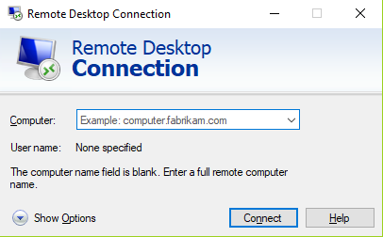

1. Change the username to **student**. And use the password mentioned in the Connection Details Panel on the left side. Click **OK**.
2. Click **Yes** to accept the certificate.

You should now see a visual interface that looks exactly like the Windows 10 OS!

If you see any error message, close the window and wait a minute or so. Sometimes the VM-creation process takes a few minutes, and you won't be able to access the VM until it's finished. This also applies to any errors that say your credentials (username and password) are incorrect.

Option 2: OS X users: Connecting to your VM via RDP

In this section, you will use Microsoft Remote Desktop 10 to connect to your windows instance using its external IP address. OSX users can [download Microsoft Remote Desktop from the Mac App Store](https://apps.apple.com/us/app/microsoft-remote-desktop-10/id1295203466?mt=12). If you are using Microsoft Remote Desktop 8, note that the interface will vary slightly than what’s listed below.

1. Open Microsoft Remote Desktop 10 application.
2. Click on **+** sign above, followed by **Add PC**.

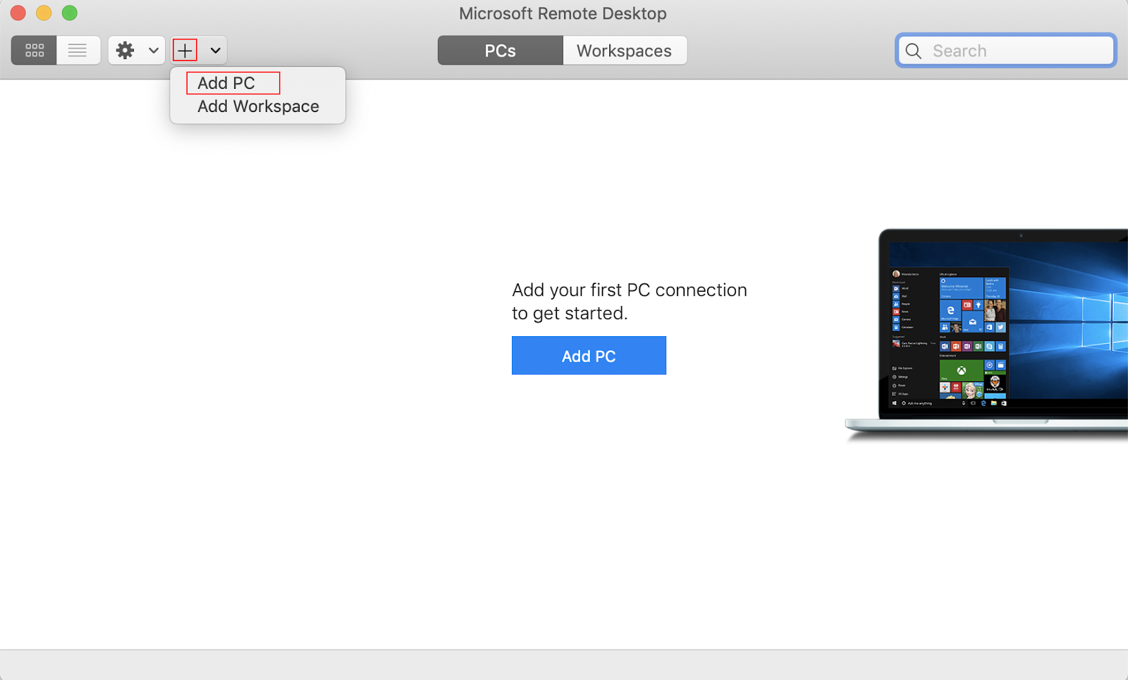

1. Enter the external IP address of the instance you want to connect to in the **PC name** field. Find the external IP address for your instance from the Connection Details Panel on the left side. Click on the **Add** button.

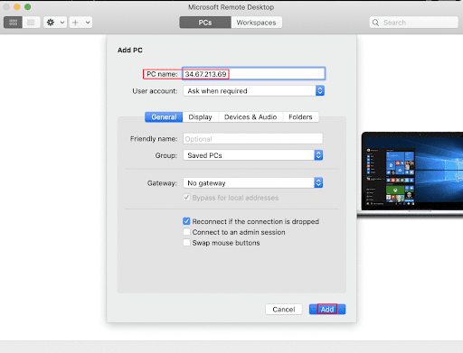

1. You should now be able to see your desktop represented by the external IP address of your VM instance under **PCs**. Double click on your VM’s external IP address.
2. The application will now prompt you for username and password. Change the username to **student**. And use the password mentioned in the Connection Details Panel on the left side. Once you have entered the details click **Continue**.
3. For any prompt regarding ‘Certificate verification’, click **continue**.

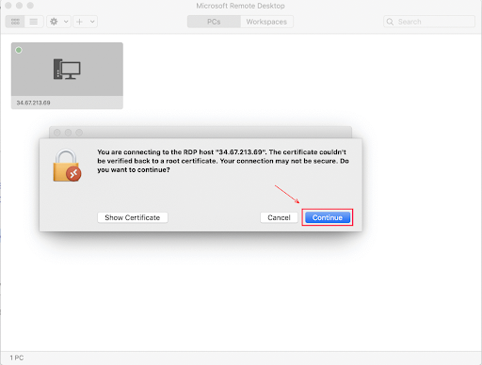

You should now see a visual interface that looks exactly like the Windows 10 OS!

If you see any error message, close the window and wait a minute or so. Sometimes the VM-creation process takes a few minutes, and you won't be able to access the VM until it's finished. This also applies to any errors that say your credentials (username and password) are incorrect.

Option 3: Chrome OS users: Connecting to your VM via RDP

In this section, you will use Chrome RDP to connect to your windows instance using its external IP address.

Chrome OS users can [download Chrome RDP from Chrome Web Store](https://chrome.google.com/webstore/detail/chrome-rdp/cbkkbcmdlboombapidmoeolnmdacpkch). Once you navigate to the download page, click on the **Add to Chrome** button. Click on **Add app** in case of any pop-ups. Then, click on **Launch app** to start the application.

1. Open the Chrome RDP application.
2. Enter the external IP address of the instance you want to connect to in the **Enter the computer name or address to connect to** field. Find the external IP address for your instance from the Connection Details Panel on the left side. Click on **connect**.
3. Leave the domain field blank. Change the username to **student**. And use the password mentioned in the Connection Details Panel on the left side. Click **OK**.
4. Click **Continue** for any window related to certificate verification.

You should now see a visual interface that looks exactly like the Windows 10 OS!

If you see any error message (an example of one is shown below), close RDP and wait a minute or so. Sometimes the VM-creation process takes a few minutes, and you won't be able to access the VM until it's finished. This also applies to any errors that say your credentials (username and password) are incorrect.

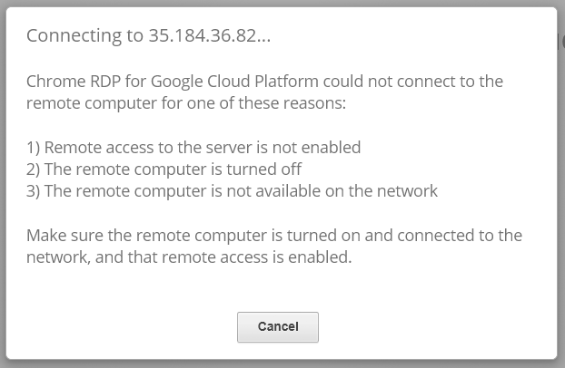

Option 4: Linux users: Connecting to your VM via RDP

In this section, you will use **Remmina** to connect to your windows instance using its external IP address. Open Remmina in your Linux machine. Linux users can [install Remmina](https://remmina.org/how-to-install-remmina/) if it is not pre-installed.

1. Open Remmina.
2. Enter the external IP address of the instance you want to connect to. Find the external IP address for your instance from the Connection Details Panel on the left side. Click on **Connect**.

Make sure the connection protocol is set to **RDP**, as shown in the image below:

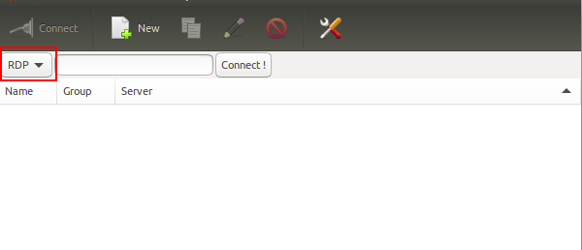

1. A window appears asking you accept the certificate, click **Ok** to continue.
2. Leave the domain field blank. Change the username to **student**. And use the password mentioned in the Connection Details Panel on the left side, for the **Password** field. Click **Ok** to continue.

You should now see a visual interface that looks exactly like the Windows 10 OS!

If you see any error message, close the window and wait a minute or so. Sometimes the VM-creation process takes a few minutes, and you won't be able to access the VM until it's finished. This also applies to any errors that say your credentials (username and password) are incorrect.

Using the Windows instance

Now you have access to the Windows instance, you're ready to start using it! This version of Windows is intended to be used on a Server, and auto-starts a server-management program. We don't need this for this lab, so wait for it to finish starting and then close it. You may see the desktop appear for a few seconds before the program launches.

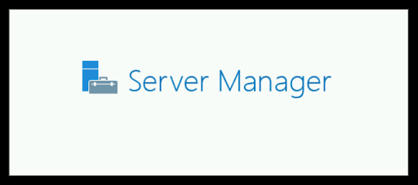 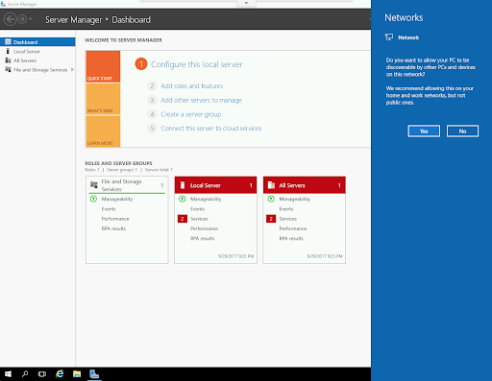

Once that's closed, the Windows OS is ready for you to use.

**Finishing the login process**

Now you‘ll see a Windows desktop background that looks like this:

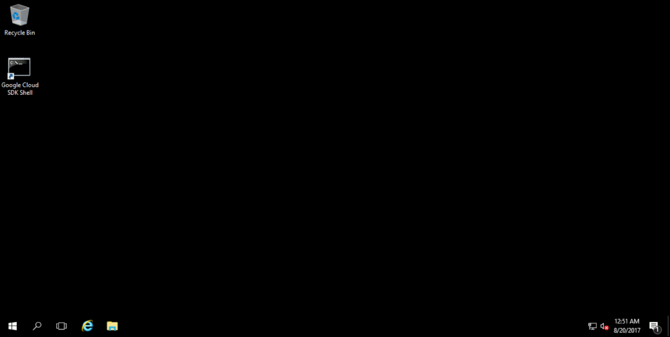

**Permissions Using Windows Powershell**

Powershell is used through the rest of the lab, and you'll need administrative privileges. Open it now by searching for "Powershell" in the start menu, then right-clicking it and selecting "Run as Administrator".

**Note**: Run the Powershell by selecting **Run as Administrator** to avoid any unexpected results.

**Example 1**

In "C:\Users\Qwiklab\Documents\" you have a file named "important_document." Your goal in this example is to change the permissions so that the user "Kara" only has read access to the file.

First, use ICACLS to view the existing permissions for the file using this command:

ICACLS C:\Users\Qwiklab\Documents\important_document

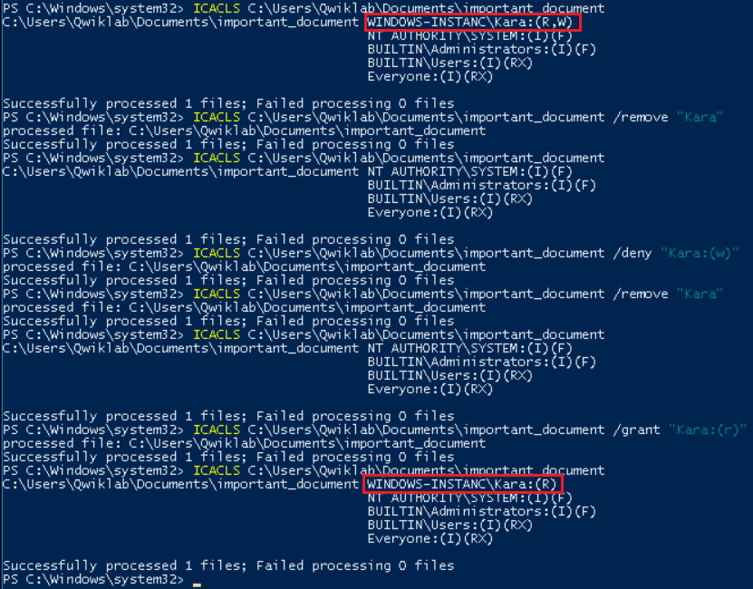

As you can see, Kara currently has read and write permissions (shown as "R" and "W"). We need her to only have read permissions, so we need to remove her write permission. An easy way to accomplish this is to remove all of Kara's permissions and then re-add her read permission. You can remove her entirely from the file's permissions and check to see that it worked with these commands:

ICACLS C:\Users\Qwiklab\Documents\important_document /remove "Kara"



ICACLS C:\Users\Qwiklab\Documents\important_document



As you can see, Kara is no longer listed in the file's permissions. To re-grant her only the read permission, use this command:

ICACLS C:\Users\Qwiklab\Documents\important_document /grant "Kara:(r)"



Now the file's permissions should be set correctly, with Kara only having read permissions. You can double check this with the earlier command:

ICACLS C:\Users\Qwiklab\Documents\important_document



Click *Check my progress* to verify the objective.

Example 1

Check my progress

**Example 2**

There's a folder called "Secret" in "C:\Users\Qwiklab\" where the user "Kara" has read access. Your goal in this example is to alter these permissions so that another user (named "Phoebe") has read permissions as well, and Kara has both read and write permissions. You can view the current permissions with this command, and see that Kara has read permissions and Phoebe is not included.

ICACLS C:\Users\Qwiklab\Secret\

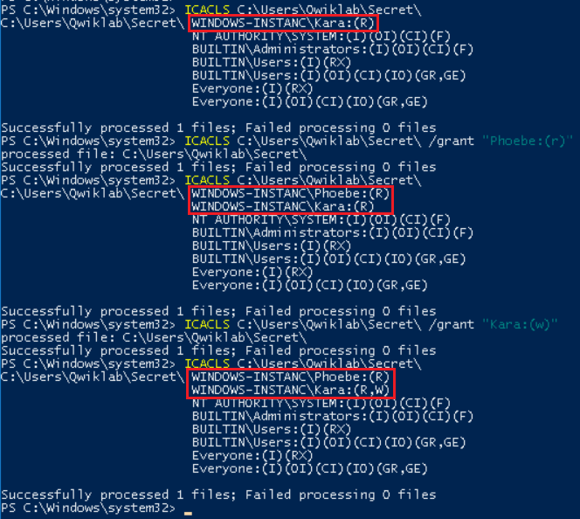

First, give Phoebe read access. You can grant her these permissions with the command below, like before. Then, use the previous command again to verify that the change has been made:

ICACLS C:\Users\Qwiklab\Secret\ /grant "Phoebe:(r)"



ICACLS C:\Users\Qwiklab\Secret\



The next step is to grant Kara write permissions. You don't need to remove her existing permissions first, like you did before; you only need to add "write" to her existing permissions with this command:

ICACLS C:\Users\Qwiklab\Secret\ /grant "Kara:(w)"



Now the file should have the required permissions. View them to verify this with the following command:

ICACLS C:\Users\Qwiklab\Secret\



Click *Check my progress* to verify the objective.

Example 2

Check my progress

**Example 3**

There's another folder in "C:\Users\Qwiklab\" called "Music". The user group, named "Everyone", has both read and write permissions for this folder. User groups are sets of local users that allow you to change multiple users' permissions at once. For example, a computer that's used by lots of employees at a business may have a usergroup called "Employees" that new hires are added to when they onboard. This automatically gives them access to everything they need, without it having to be set manually. The "Everyone" group is created by default, and every new user is automatically added.

Your goal for this example is to change the permissions for this folder so that the "Everyone" group only has read permission (not write).

As usual, view the current permissions with this command:

ICACLS C:\Users\Qwiklab\Music\

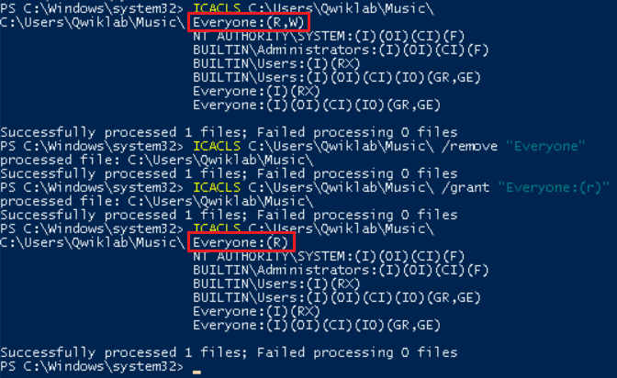

You can change permissions for groups in exactly the same way as you do for users. To remove the group's current permissions, and then re-grant them a read permission, use these commands:

ICACLS C:\Users\Qwiklab\Music\ /remove "Everyone"

ICACLS C:\Users\Qwiklab\Music\ /grant "Everyone:(r)"



The "Everyone" group should now have only read permissions, which you can check using the same command as before:

ICACLS C:\Users\Qwiklab\Music\



Click *Check my progress* to verify the objective.

Example 3

Check my progress

**Example 4**

Back in the "documents" folder from before, there's a file called "not_so_important_document". In this example, you need to modify the permissions for that file so that the group called "Authenticated Users" has "Write" access. The "Authenticated Users" group is another automatically created group, containing all users with admin privileges. View the current permissions with this command, to see what the starting point for this file is:

ICACLS C:\Users\Qwiklab\Documents\not_so_important_document

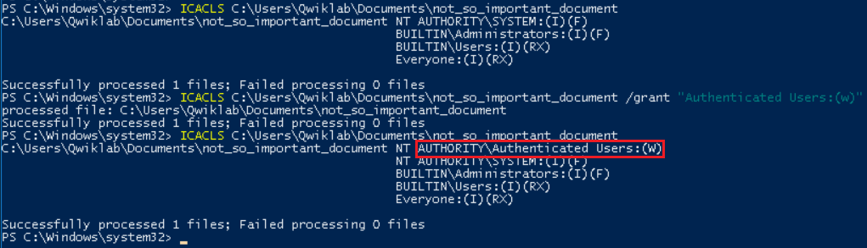

This will show you that the "Authenticated Users" group is currently not listed. This means that the only step required is to grant them write access, which you can do with this command:

ICACLS C:\Users\Qwiklab\Documents\not_so_important_document /grant "Authenticated Users:(w)"



That should successfully grant them write permissions. You can use the same command as earlier to verify that the commands were a success:

ICACLS C:\Users\Qwiklab\Documents\not_so_important_document



Click *Check my progress* to verify the objective.

Example 4

Check my progress

**Example 5**

In this final example, you'll change the permissions of another file in the "Documents" folder. The file named "public_document" needs to be made publically readable, so that anyone on the system is able to read it. As usual, view the file's commands first:

ICACLS C:\Users\Qwiklab\Documents\public_document

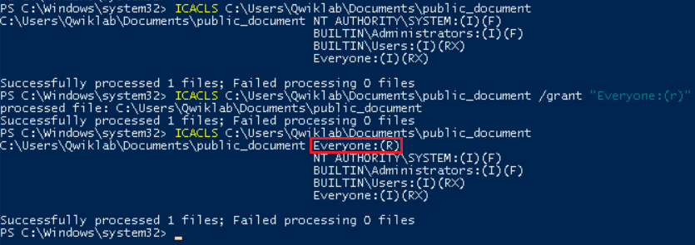

The easiest way to make sure that all users on the system have read permissions is to add those permissions to the "Everyone" group. You could also add each user manually, but by giving the group the permissions instead, you save time; it removes the need to go back and edit permissions again if a new user is created in the future. Grant every user on the system the ability to read the file using this command:

ICACLS C:\Users\Qwiklab\Documents\public_document /grant "Everyone:(r)"



Finally, view the permissions again to make sure it worked:

ICACLS C:\Users\Qwiklab\Documents\public_document



Click *Check my progress* to verify the objective.

Example 5

Check my progress

**Conclusion**

Wohoo! You've successfully used Powershell to modify the permissions for both files and directories. You modified the permissions by granting and removing specific permissions using ICACLS. You've also become familiar with groups of users, and how to modify permissions for them as well. Really well done.